Complexity index | bin (Da)
Complexity index | <150 | <200 | <250 | <300 | <350 | <400 | <450 | <500 | <550 | <600 | >600
Bertz | 390 | 520 | 673 | 845 | 1043 | 1230 | 1456 | 1644 | 1784 | 2052 | 2540
Barone | 281 | 360 | 438 | 522 | 607 | 695 | 795 | 884 | 968 | 1085 | 1408
Whitlock | 19 | 22 | 25 | 28 | 32 | 36 | 42 | 47 | 51 | 64 | 81
SMCM | 21.7 | 33.7 | 40.1 | 46.2 | 49.5 | 55.2 | 63.5 | 70.0 | 81.3 | 100.7 | 128.9
Table S1 Threshold values of complexity indices for various MW bins. The threshold value was determined as 999th permiles of complexity index distribution in 22 723 223 ZINC compounds. For example, 99.9% ZINC compounds with MW between 150 Da and 200 Da have Bertz index less than 520.

SYBA, default threshold (0.0)  SAScore, default threshold (6.0)  RF, default threshold (0.5) | SYBA, optimal threshold (18.7)  SAScore, optimal threshold (3.8)  RF, optimal threshold (0.5)  SCScore, optimal threshold (4.0)
   | Actual ES | Actual HS
  Predicted ES | 31 | 7
  Predicted HS | 9 | 33
   | Actual ES | Actual HS
  Predicted ES | 35 | 28
  Predicted HS | 5 | 12
   | Actual ES | Actual HS
  Predicted ES | 31 | 9
  Predicted HS | 9 | 31
   | Actual ES | Actual HS
  Predicted ES | 31 | 4
  Predicted HS | 9 | 36
   | Actual ES | Actual HS
  Predicted ES | 31 | 2
  Predicted HS | 9 | 38
   | Actual ES | Actual HS
  Predicted ES | 31 | 8
  Predicted HS | 9 | 32
   | Actual ES | Actual HS
  Predicted ES | 25 | 16
  Predicted HS | 15 | 24
Panel S1 Confusion matrices of the classification of the manually curated T_{MC} test set. Out of possible 30 T_{MC} sets differing in T_{MC+} compounds, confusion matrices are reported for the T_{MC} set with the smallest SYBA AUC (0.841).

SYBA, default threshold (0.0)  SAScore, default threshold (6.0)  RF, default threshold (0.5) | SYBA, optimal threshold (4.13)  SAScore, optimal threshold (3.9)  RF, optimal threshold (0.6)  SCScore, optimal threshold (3.9)
   | Actual ES | Actual HS
  Predicted ES | 37 | 7
  Predicted HS | 3 | 33
   | Actual ES | Actual HS
  Predicted ES | 40 | 28
  Predicted HS | 0 | 12
   | Actual ES | Actual HS
  Predicted ES | 38 | 9
  Predicted HS | 2 | 31
   | Actual ES | Actual HS
  Predicted ES | 37 | 6
  Predicted HS | 3 | 34
   | Actual ES | Actual HS
  Predicted ES | 34 | 3
  Predicted HS | 6 | 37
   | Actual ES | Actual HS
  Predicted ES | 36 | 6
  Predicted HS | 4 | 34
   | Actual ES | Actual HS
  Predicted ES | 29 | 18
  Predicted HS | 11 | 22
Panel S2 Confusion matrices of the classification of the manually curated T_{MC} test set. Out of possible 30 TMC sets differing in TMC+ compounds, confusion matrices are reported for the TMC set with the smallest SYBA AUC (0.947).

SYBA, default threshold (0.0)  SAScore, default threshold (6.0)  RF, default threshold (0.5) | SYBA, optimal threshold (-16.6)  SAScore, optimal threshold (4.5)  RF, optimal threshold (0.2)  SCScore, optimal threshold (3.0)
   | Actual ES | Actual HS
  Predicted ES | 3214 | 0
  Predicted HS | 367 | 3581
   | Actual ES | Actual HS
  Predicted ES | 3580 | 2446
  Predicted HS | 1 | 1135
   | Actual ES | Actual HS
  Predicted ES | 2880 | 1
  Predicted HS | 701 | 3580
   | Actual ES | Actual HS
  Predicted ES | 3498 | 14
  Predicted HS | 83 | 3567
   | Actual ES | Actual HS
  Predicted ES | 3527 | 23
  Predicted HS | 54 | 3558
   | Actual ES | Actual HS
  Predicted ES | 3464 | 62
  Predicted HS | 117 | 3519
   | Actual ES | Actual HS
  Predicted ES | 1278 | 699
  Predicted HS | 2303 | 2882
Panel S3 Confusion matrices of the classification of the computationally picked T_{CP} test set.

SAScore, default threshold (6.0) | SAScore, optimal threshold (4.4)  SCScore, optimal threshold (3.7)
   | Actual ES | Actual HS
  Predicted ES | 692 058 | 321 483
  Predicted HS | 1 295 | 371 870
   | Actual ES | Actual HS
  Predicted ES | 648 301 | 47 391
  Predicted HS | 45 052 | 645 962
   | Actual ES | Actual HS
  Predicted ES | 391 138 | 220 575
  Predicted HS | 302 215 | 472 778
Panel S4 Confusion matrices of the classification of the S training set.

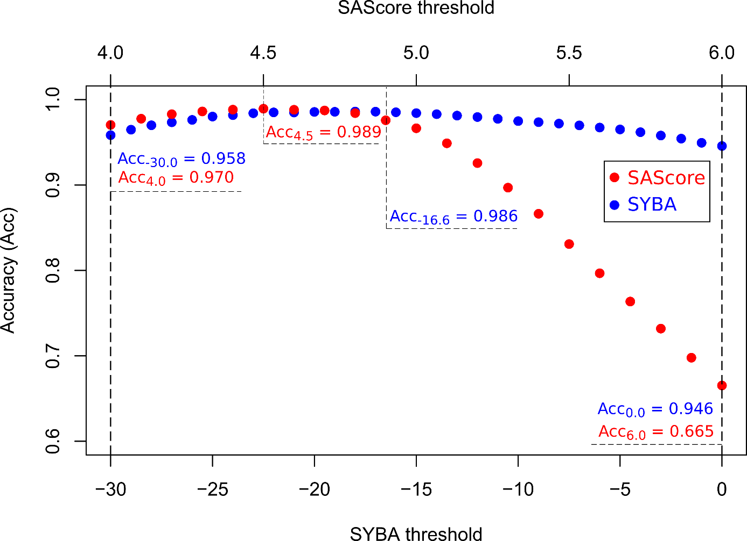
Figure S1 The dependency of the accuracy of the classification of T_{CP} compounds on SYBA and SAScore thresholds. Shown threshold intervals (from -30.0 to 0.0 for SYBA and from 4.0 to 6.0 for SAScore) cover roughly 20 % of all plausible values of SYBA (from -100 to 70) and SAScore (from 1 to 10). Ends of shown threshold intervals are given as implicit thresholds of SYBA (0.0) and SAScore (6.0). Over their respective threshold intervals, SYBA is more robust than SAScore. While for SYBA the difference in the accuracy between optimal and recommended thresholds is only 0.04, this difference equals to 0.324 for SAScore.

